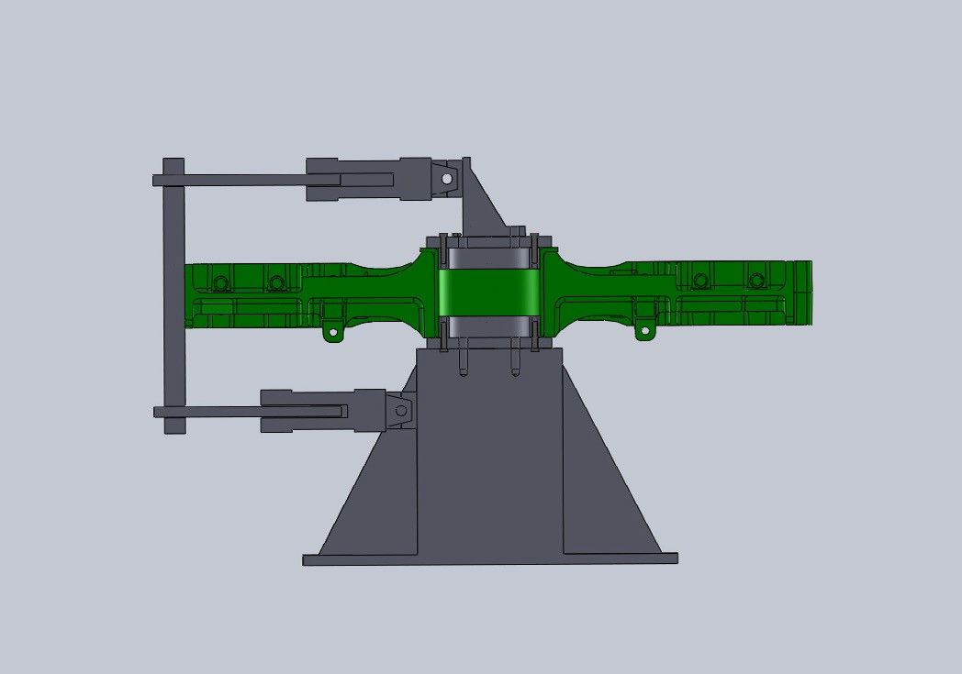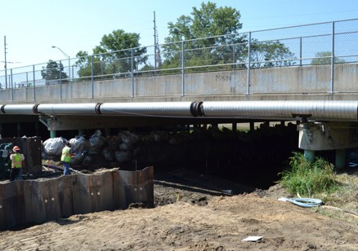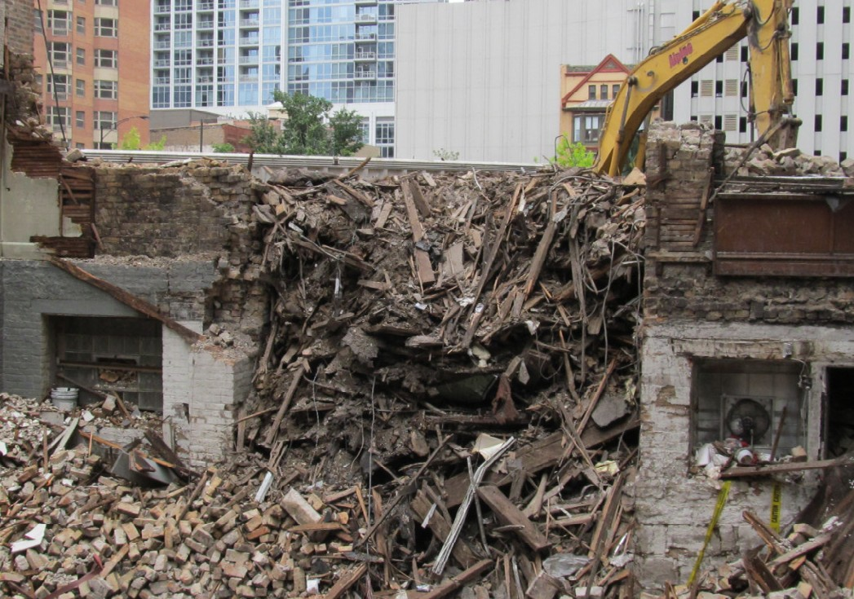Adjacent Construction
Risk Management

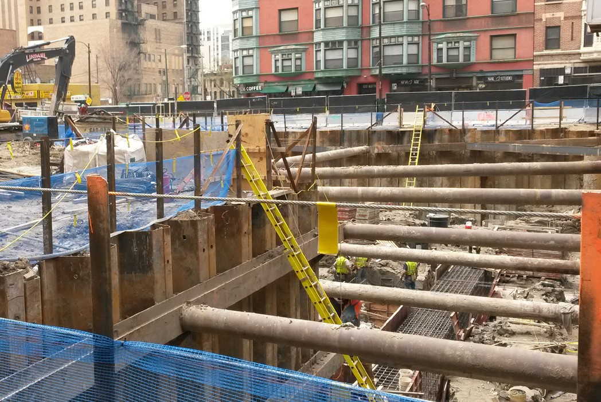In dense urban environments and other sensitive areas, new construction, demolition, redevelopment and related activities carry a risk of unintended effects on neighboring structures and facilities. Building on strong backgrounds in soil/structure interaction, dynamics, forensic engineering, and monitoring, CTLGroup experts help our clients reduce the likelihood and severity of such side effects.

Common Concerns Some common concerns related to construction and related activities adjacent to existing facilities, and related services offered by CTLGroup include:
• Vibration– consulting and field monitoring to evaluate ground-borne and
structural vibrations and their effects.
• Cracking – pre-construction surveys to catalog existing cracks, and quasi-
static and dynamic monitoring of crack response to construction and
other activities and environmental effects.
• Movement– settlement and rotation of super- or substructure elements
due to changes in support condition
• New or different load patterns– adjacent activities can influence
magnitude and distribution of loads on a structure, requiring in-depth
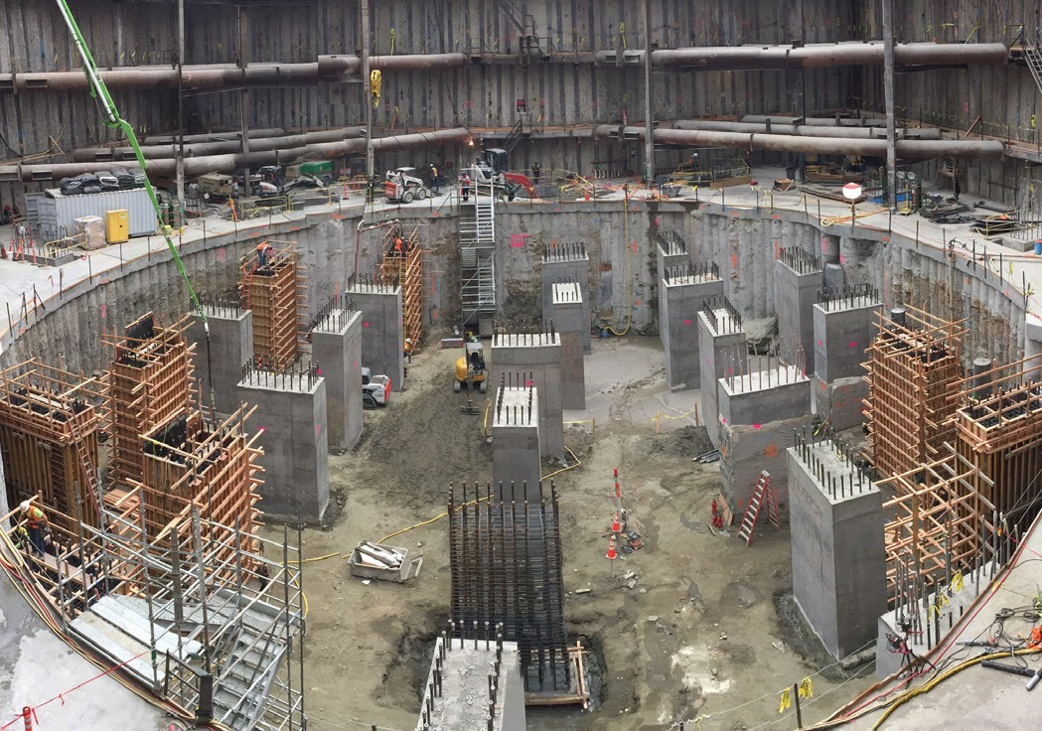evaluation.

CTLGroup has been retained by owners, designers, contractors, and other parties on both sides of the property line. As independent experts, CTLGroup engineers are well-equipped to help avoid losses or disputes related to adjacent construction as well as provide expert testimony when cases do go to litigation.

www.CTLGroup.com

